

***School of Mechanical & Manufacturing Engineering (SMME),***

***National University of Science and Technology (NUST),***

***Sector H-12, Islamabad***

Program: BE-Aerospace Section: AE-01

Session: Spring 2024 Semester: 2nd

Course Title: Engineering Drawing and Graphics(AE-103)

**AUTOCAD ASSIGNMENT**

Submitted to

Lab Engr. Laiba Waheed

**Name: Hadia Khan**

**CMS:** **455885**

**Date: 10-05-2024**

Contents

**INTRODUCTION** 4

**AUTOCAD** 4

**BASIC TOOLS DESCRIPTION** 4

**Line** 4

**Circle** 4

**Rectangle** 4

**Polyline** 4

**Copy** 4

**Rotate** 4

**Erase** 4

**Trim** 4

**Move** 4

**Mirror** 4

**Offset** 5

**Array** 5

**Fillet** 5

**LAYERS** 5

**LINETYPE COMMAND** 5

**Dimension Style Manager (DIMSTYLE)** 6

**ASSIGNMENT DRAWINGS VIEWS** 8

**Drawing 01** 8

Front View 8

Top View 8

Left Hand Side View 9

**Drawing 02** 10

Front View 10

Top View 10

Left Hand Side View 11

**Drawing 03** 12

Front View 12

Top View 12

Right Hand Side View 13

# **INTRODUCTION:**

This report provides a foundational understanding of Autocad software. It provides a clear introduction to the essential AutoCAD tools and functions. All the stated tools serve as building blocks for creating accurate 2D drawings, helping in translating engineering concepts and drawings into digital form.

# **AUTOCAD:**

AutoCAD, developed by Autodesk, is a prominent software application within the realm of Computer-Aided Design (CAD). It excels in creating both 2D and 3D technical drawings with a high degree of precision. Professionals like architects, engineers, and drafters utilize AutoCAD extensively to generate floor plans, mechanical schematics, and various other technical illustrations. This software goes beyond basic drafting by offering functionalities for data extraction, collaboration features, and the ability to import and modify existing drawings. This versatility translates to enhanced workflows, streamlined revision processes, and even the conversion of legacy hand-drawn plans into digital formats. Furthermore, AutoCAD boasts a library of pre-designed symbols and objects, which significantly improves efficiency by allowing users to focus on the creative aspects of their projects.

# **BASIC TOOLS DESCRIPTION:**

**Line:** This tool allows the user to draw a straight line between two points in a CAD drawing. For instance, it can be used to create walls and partitions in architectural drawings, furthermore, in drawing basic geometric structures.

**Circle:** This tool is used to construct a round shape of constant radius or diameter in CAD designs. For instance, it is used in drawing gears, and wheels, representing holes and openings in engineering drawings.

**Rectangle:** This tool allows the user to construct a four-sided shape with equal side lengths and right angles.

**Polyline:** This tool is used to create a continuous line composed of one or more line segments.

**Copy:** This tool copies objects at a specified distance.

**Rotate:** This tool rotates an object around a base point.

**Erase:** It removes the selected object from the drawing.

**Trim:** This tool is used to trim objects to meet the edges of other objects.

**Move:** This tool moves objects from one location to another.

**Mirror:** It is used to create a mirrored image of selected objects.

**Offset:** This tool is used to create parallel or concentric copies of lines, polylines, circles, or arcs.

**Array:** It is used to create multiple copies of objects in a pattern.

**Fillet:** This tool is used to create a rounded corner between two lines.

# **LAYERS:**

In AutoCAD, layers are used to organize objects within a drawing. It allows users to:

1. Associate objects by their function or location
2. Display or hide all related objects in a single operation
3. Enforce linetype, color, and other property standards for each layer.

# **LINETYPE COMMAND:**

The linetype command allows the user to load, set, and modify linetypes.

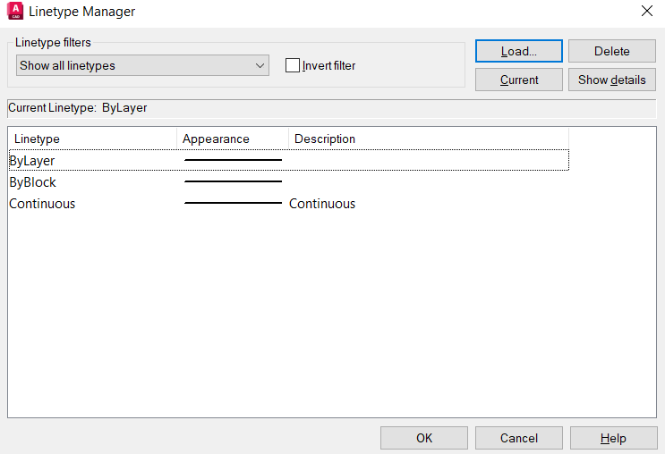

# **Dimension Style Manager (DIMSTYLE):**

The **Dimension Style Manager** allows the user to:

* + - Adjust dimension settings (such as text, lines, and symbols).
    - Create, modify, and manage dimension styles.

In **AutoCAD**, the DIMSTYLE command is essential for creating and modifying dimension styles. A dimension style is a named collection of settings that controls how the dimensions will appear in drawings. These settings include properties like text height, arrowheads, extension lines, dimension lines, etc.

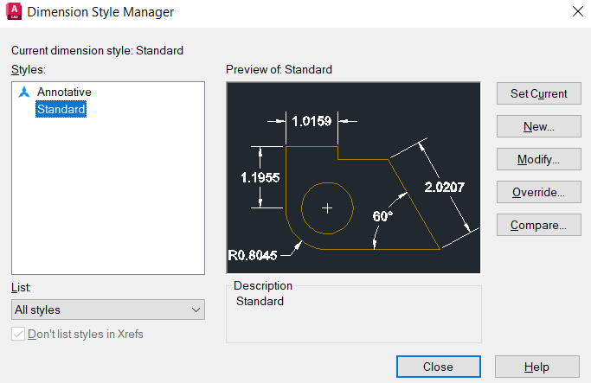

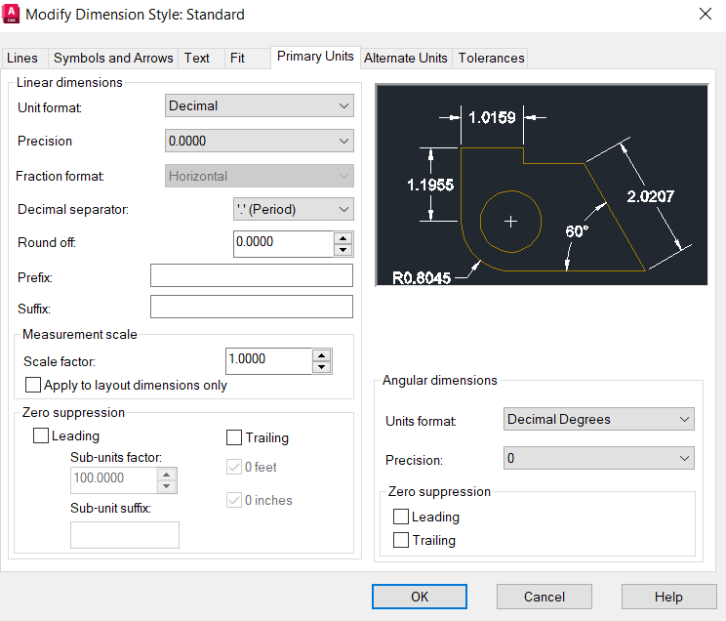

# **ASSIGNMENT DRAWINGS VIEWS**

## **Drawing 01**

### Front View

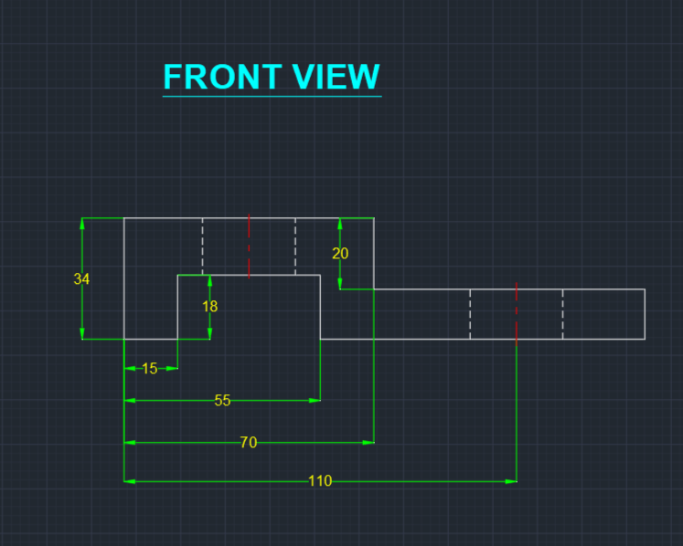

### Top View

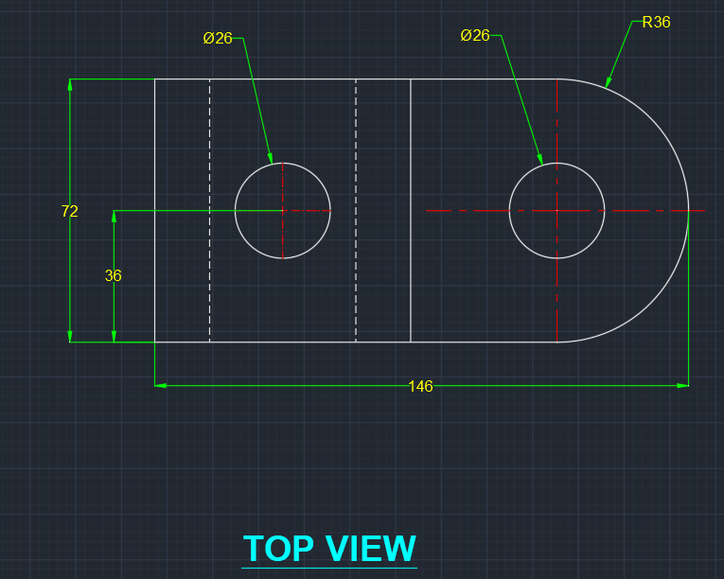

### Left Hand Side View

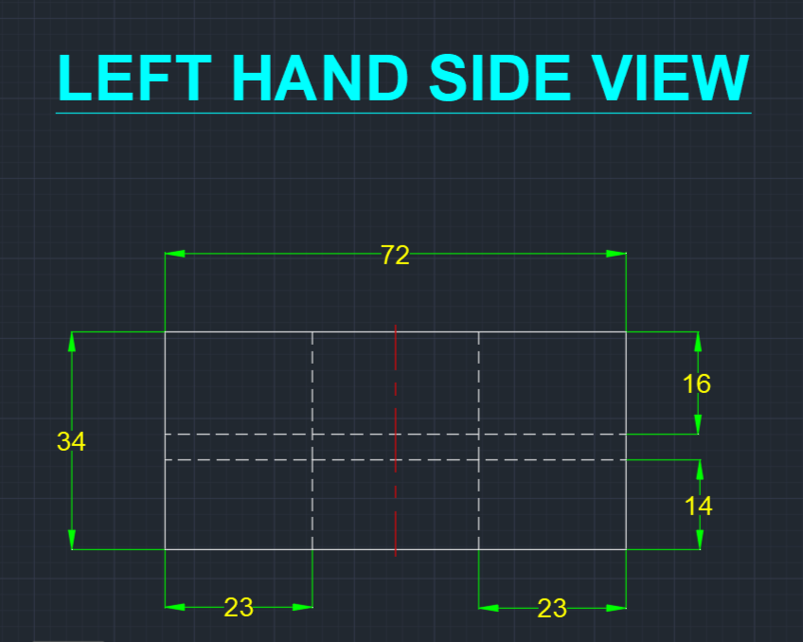

## **Drawing 02**

### Front View

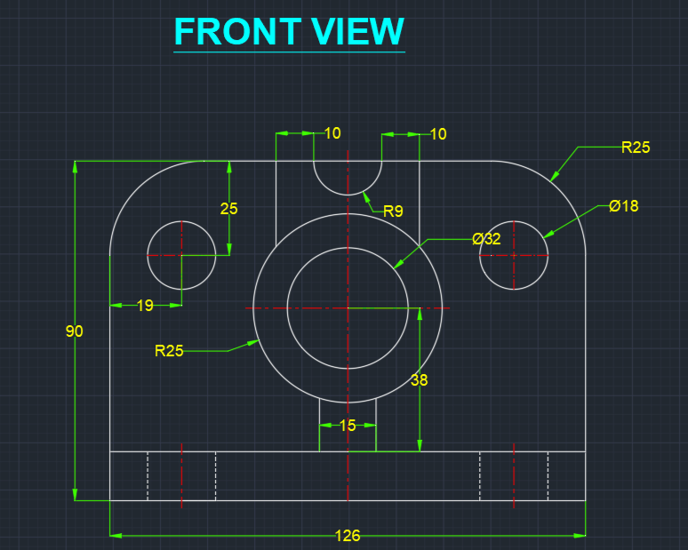

### Top View

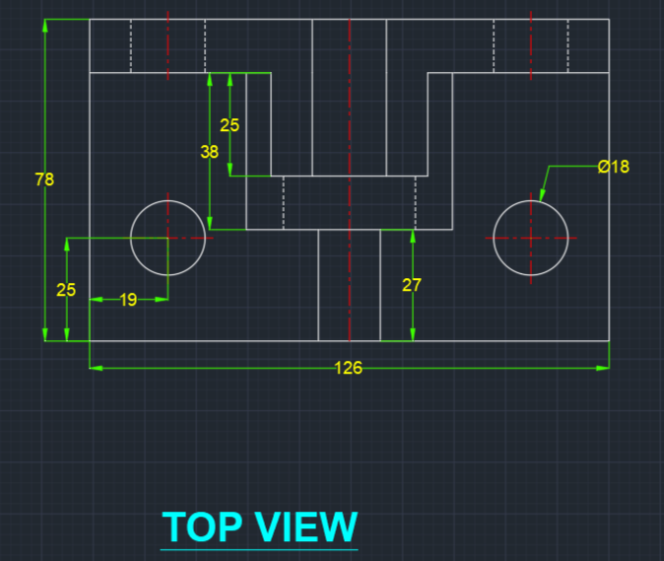

### Left Hand Side View

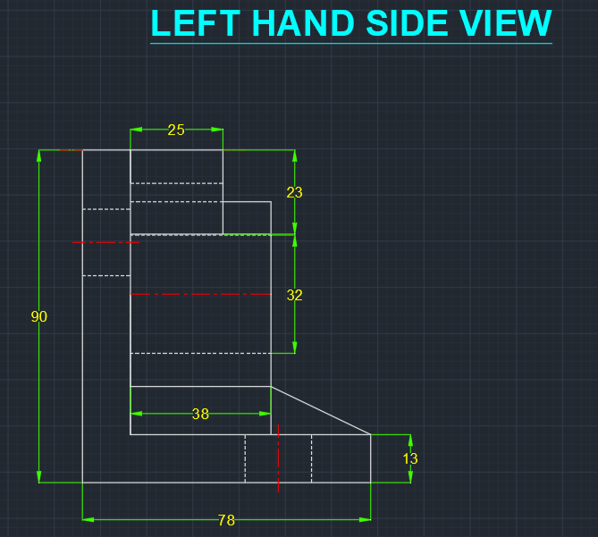

## **Drawing 03**

### Front View

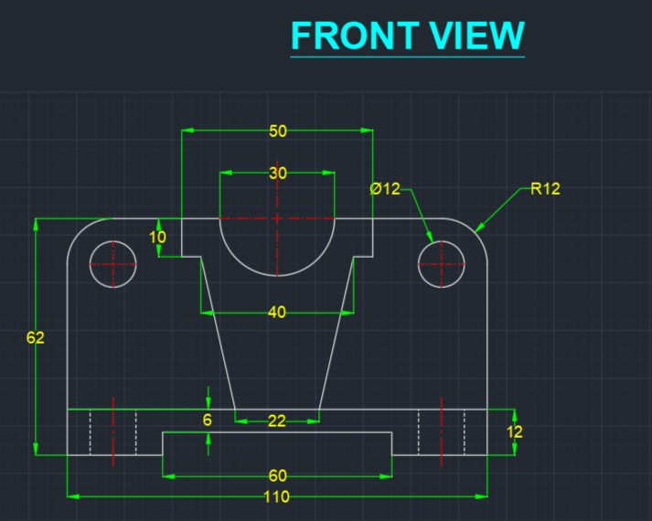

### Top View

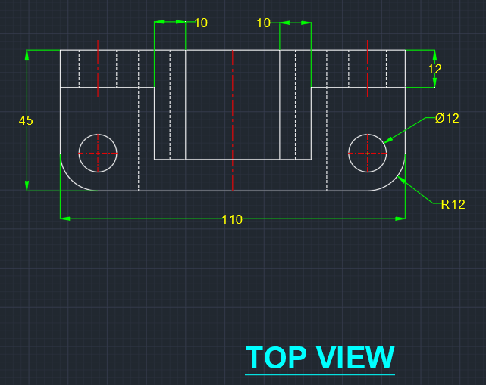

### Right Hand Side View

